I have started doing 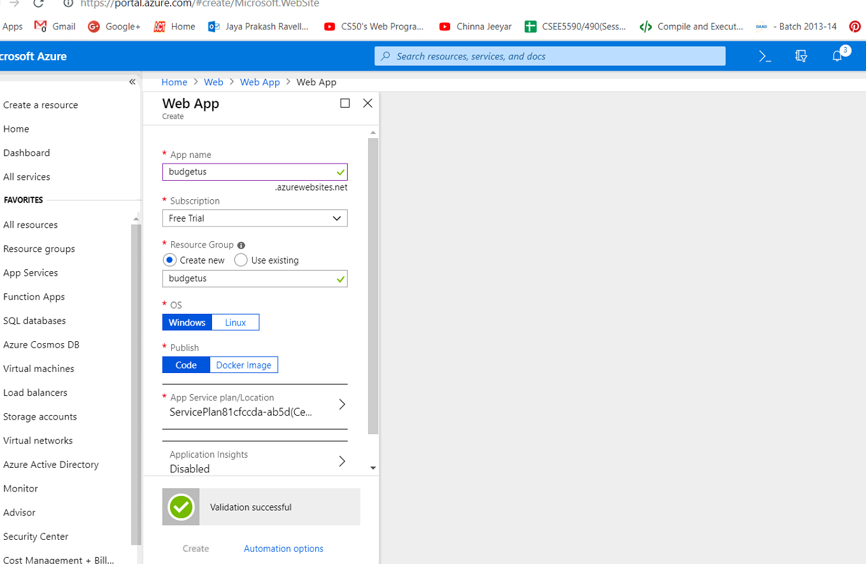web app in the azure

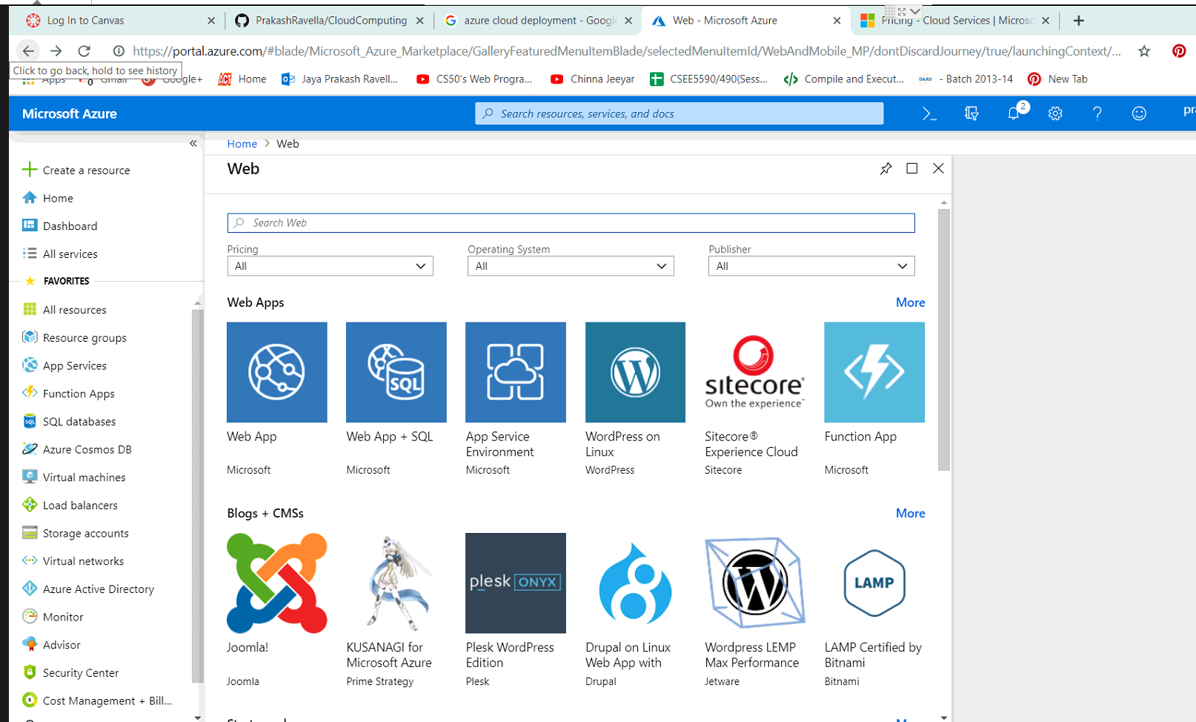

I can complete the code and deploy the web service using the cloud

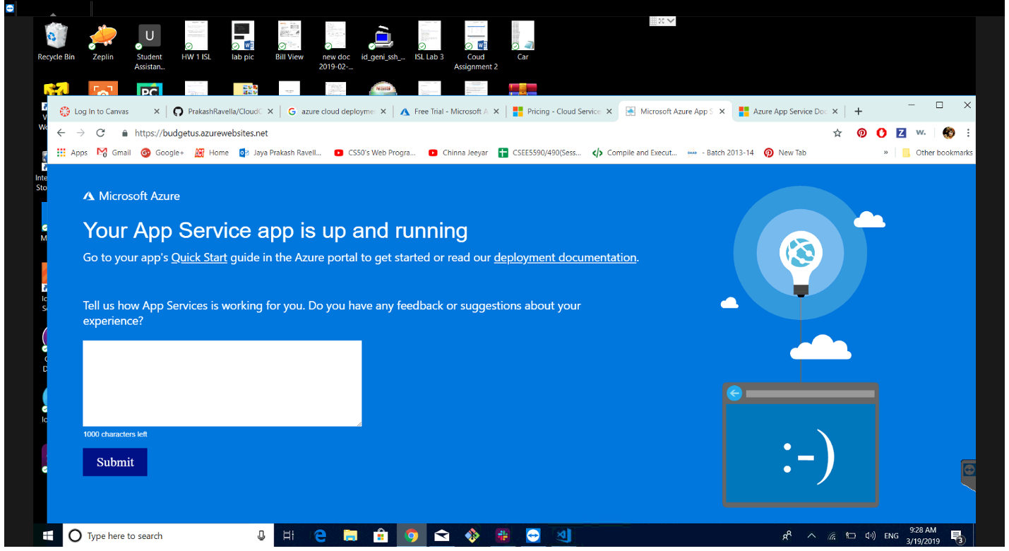

I have started working on the UI part of the code and will update very soon !